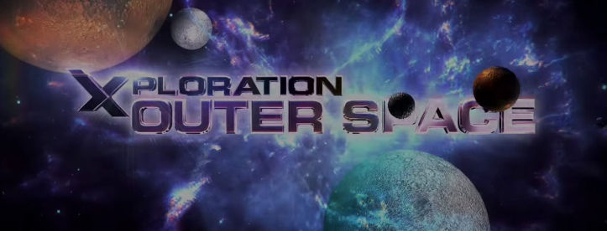
Name:________________________

PART 1: Laws of Motion
- How many years ago were rockets invented? OVER 2,000 YEARS AGO
- What country invented rockets? CHINA
- Are fireworks considered rockets? YES
- What is another word for “payload”? CARGO
- What is one example of a payload that a rocket might carry? A SATALITE
- Does the second stage of a rocket have an engine and fuel tanks? YES
- Why are these able to smaller?
- What is the name of the scientist who came up with the three laws of motion? SIR ISSAC NEWTON
- What is the first of these laws? INERTA
- Define it. An object in motion will stay in motion. An object at rest will stay at rest.
- What is Newtion’s second law of motion? FORCE = MASS x ACCELLERATION
- Define it. If you push with a greater force, your end up with greater acceleration
- What is Newtion’s third law of motion? Equal and Opposite Reactions
- Define it. If you push on an object with a certain force, it also pushes on you with the same force.
- What object gets blown-up to show all three laws?
PART 2: Building a Rocket
- What two types of rockets are built at the building the TV show went to? DELTA AND ATLAS ROCKETS
- What was the name of the first United States Astronaut to orbit the planet Earth? JOHN GLENN
- What type of rocket was he on? ATLAS
- How fast was the ATLAS rocket that broke the speed record? 35,800 MPH
- What type of metal is used to start the rocket building process? ALUMINUM
- How do engineers make the aluminum lighter but keep it’s strength? CUT TRIANGLE PATTERNS IN IT
- Would a match burn in space? NO
- Why? NO OXYGEN

PART 3: Test of a Rocket Engine

