Name:_________________________________________
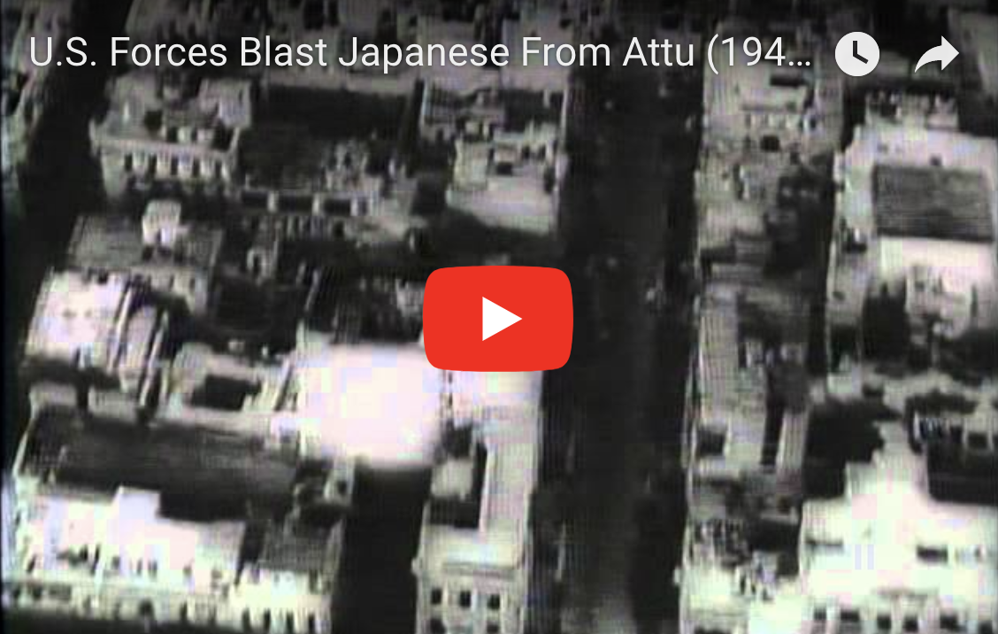
U.S. Forces Blast Japanese From Attu (1943):
www.youtube.com/watch?v=4A-mWNnxg-k

- When was this movie made? (look at the information below the YouTube video)

- The word “Jap” is used and said several times during this video. It was a word that some people used during World War 2 when talking about people from Japan. It is very important to understand that this word is not appropriate to say now. We spoke on Monday about the names that people called Martin Luther King Jr., and how people do not speak that way now. This is the same idea. It is NOT OK to call someone a “Jap” now. What is the title of this part of the movie that you are watching? 0:37

- Attu Island is an island in the ___________________ Chain. 1:00

- What is the name of the boat at 1:08? (it is written on the back of it)

- How many miles away from Attu Island was Japan’s large naval base? 1:20

- What Japanese vehicles were all over the beach when the American’s arrived to try and take it back? 2:03

- How many people did it take to fire the large canon at 2:15?

- What is the title of the section of video at 2:20?

- What enemy ship did the ship’s lookout see at 3:17?

- What vehicle did the US water explosives force to the surface at 3:46?

When you are done answering Question #10 Please watch the sled dog video on the Alaska Page on our class Website.

Write down at least three things that you noticed about the dogs used in the Iditarod.

1.

2.

3.

