The Whale Hunters
https://www.youtube.com/watch?time_continue=796&v=20y7p_kENOM
- What city is Alaska are the whale hunters from? 0:20

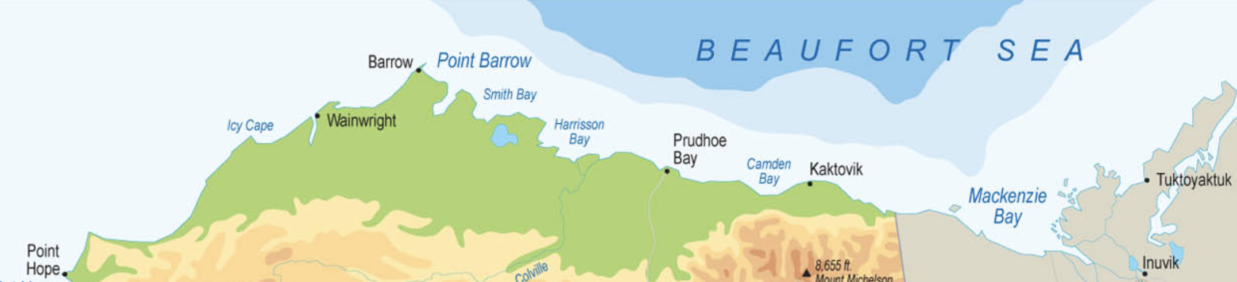

- What makes hunting on first year ice so dangerous? 1:50

- What kind of whales are they hunting? 2:03

- How many hunters in usually in a crew? 2:35

- List the whale hunter’s tactics 3:15
First:
Second:
Third:
Fourth:

- Why is the moment that the harpooner strikes the whale the most dangerous part of the whale hunt? 3:45

- What is the custom for hunters to do after it is dead? 4:28

- Recently, how many Eskimo women were killed when the block-and-tackle slipped? 6:30

- How much time did one of the crew say it would take to pull up the whale and butcher it? 6:48

- The first whale is traditionally divided among who? 7:25
- What do you think the kids are sticking their fingers into at 7:56?

- Once the crews all get their meat, where who gets the remaining meet? 8:09

- What kind of injury did the biologist discover on the killed whale? 9:40

- Harpoons more than a century old have been found inside whales! How long is a century?

- In 1992, a bowhead was killed that had an amazing artifact inside it. What was the artifact? 10:35

- Please watch the rest of the video and share what you thought of it below.

