Name:______________________ Date:____________________ © D. Thomassen 2006

"The Blind Hunter"
by Kristina Rodanas
Pages 448-463 in Treasures

Genre: Realistic Fiction (a made-up story that could have happened in real life).

Directions: After reading this text, complete the following organizer parts. Remember to reread any part of the story that confused you. You are a great reader.

Part I: Vocabulary Preinstruction:

Vocabulary Word: | How it is used in this story:
fade | “Before my eyes began to fade I, too, was a hunter,” said Chirobo.
cautiously | Cautiously, he pushed aside the dense bushes and scanned the surrounding landscape.
crisscrossed | Countless tracks of birds crisscrossed the soft, muddy bank.
disguised | After he had disguised both traps, the young man said, “We will camp nearby and return tomorrow. Then we will see what we have caught.”
wisdom | Muteye grew to admire the blind man’s wisdom and asked him questions about which he had wondered for a long time.
jealousy | As he kneeled down to look inside, his heart filled with jealousy.
faint | In a faint voice, Muteye asked, “How does a man who has been unkind earn the forgiveness of his friend?”

1. visual (“Follow along with your eyes as I spell it out loud”)
2. auditory (Hear the parts /p/ /ea/ /ch/)
3. kinesthetic (trace with eyes, write it on the table, hand, etc.)
4. phonics (break the word apart)—discuss prefixes, suffixes, roots, compounds, phonograms, double vowels, silent e.
5. meaning (give the definition and/or an example)
6. give an example. “I will be working with this group, meanwhile, this group will be at computers.”

-------------------------------------------------------------------------------------------------------------------
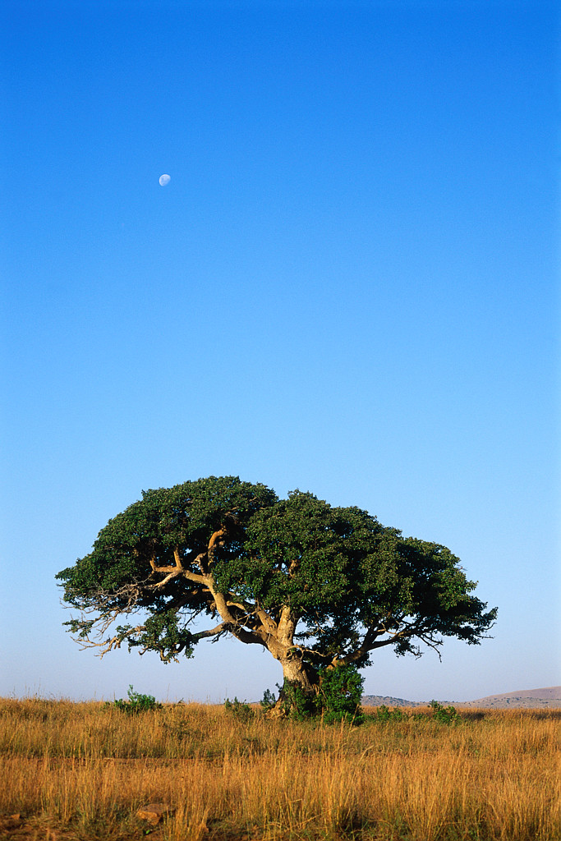

Part II: Comprehension

1. As you read this realistic fiction story, fill in any information you learn about the setting, main characters, plot, problem, and, finally, the climax (solution):

What is the setting of this story (time and place)?  _____________________________  _____________________________  _____________________________  _____________________________  _____________________________  _____________________________  _____________________________  _____________________________  _____________________________ | Who are the main characters? Write down something important about each character.  _____________________________  _____________________________  _____________________________  _____________________________  _____________________________  _____________________________  _____________________________  _____________________________  _____________________________ |  | What is the plot (what is happening in this story)?  _____________________________  _____________________________  _____________________________  _____________________________  _____________________________  _____________________________  _____________________________  _____________________________  _____________________________
What is the problem in this story?  ____________________________________________  ____________________________________________  ____________________________________________  ____________________________________________  ____________________________________________  ____________________________________________  ____________________________________________  ____________________________________________  ____________________________________________ |  | What was the solution to the problem (usually the solution is the climax)?  ____________________________________________  ____________________________________________  ____________________________________________  ____________________________________________  ____________________________________________  ____________________________________________  ____________________________________________  ____________________________________________  ____________________________________________
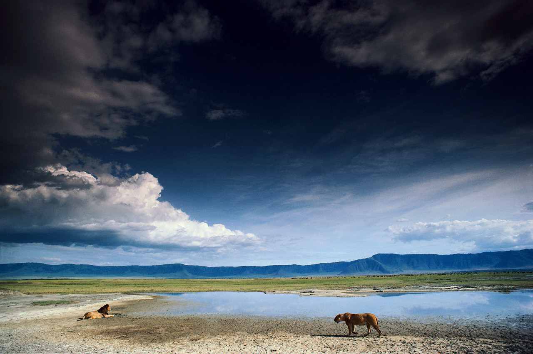

2. Why did Muteye hesitate when Chirobo asked to go hunting with him?

__________________________________________________________________________________________

__________________________________________________________________________________________

3. In the text it says, “The young man led the way, holding the end of a long, straight walking stick. Behind him the blind man followed, clutching the other end.” Another word for clutching is…

dropping

walking

twisting

grasping

4. How was Chirobo able to warn Muteye about the following animals? Complete the following grid by writing in how Chirobo knew the animal was nearby and whether or not you knew this from specific textual evidence or from an inference (logical guess).

Animal | How did Chirobo know this animal was nearby? | Text Evidence: | Inference:
leopard
warthogs |  | √
rhinos | He was able to feel the ground and test for tracks.

5. In the text it says that Chirobo “placed his hands upon the ground.” How did this method help Chirobo determine that a certain animal was in the area?

__________________________________________________________________________________________

__________________________________________________________________________________________

__________________________________________________________________________________________

__________________________________________________________________________________________

6. In the text it says, “The young man checked his own trap first and discovered that he had caught a small, thin quail. Although he was disappointed, he carefully removed it and put it into a goatskin sack Then he went to check the other trap.”

Which word in this section means the same as upset?_________________________
7. Muteye asks Chirobo, “Why do people fight each other?” If someone asked you this question, what would you tell them (you do not need to mention anything about Chirobo’s answer—please share your own thoughts).

__________________________________________________________________________________________

__________________________________________________________________________________________

__________________________________________________________________________________________

__________________________________________________________________________________________

__________________________________________________________________________________________

__________________________________________________________________________________________

8. Discuss two things that might have happened to Muteye if Chirobo had not accompanied him on the hunt?

a.________________________________________________________________________________________

b.________________________________________________________________________________________

9. Sequence: Put the following events from the story in the proper ordering by placing a 1 in front of the event that occurred first, a 2 in front of the event that occurred second and so on:

_____Chirobo asked if he could go and hunt with Muteye.
_____Chirobo and Muteye set traps for birds.
_____Chirobo warned Muteye about the warthogs and rhinos.
_____Chirobo shared a meal with Muteye, who had traveled a long distance.
_____Muteye is jealous of Chirobo and switches the birds.
_____Chirobo tells Muteye why people fight each other.
_____Chirobo worked hard in his garden.
_____Chirobo warned Muteye about the sleeping leopard.

10. What was the author’s purpose in writing this story?

__________________________________________________________________________________________

__________________________________________________________________________________________

__________________________________________________________________________________________
---------------------------------------------------------------------------------------------------------------------------------------

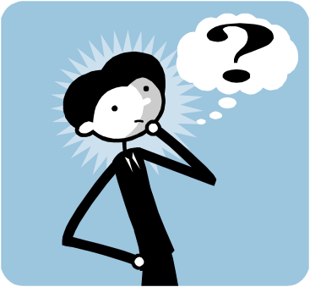

Part III: Compare and Contrast

Analogies: We use analogies to identify relationships between pairs of concepts (Marzano 2001).

Examples: happy:sad::big:small ("happy is to sad as big is to small")

Directions: Complete these analogies that were created from the text you just read.

faint:strong::_______________:reckless

Africa:continent::Kenya:_______________

blind:_______________::deaf:ears

touch:hands::hear:_______________

questioned:inquired::wise:_______________

trap:_______________::stop:pots

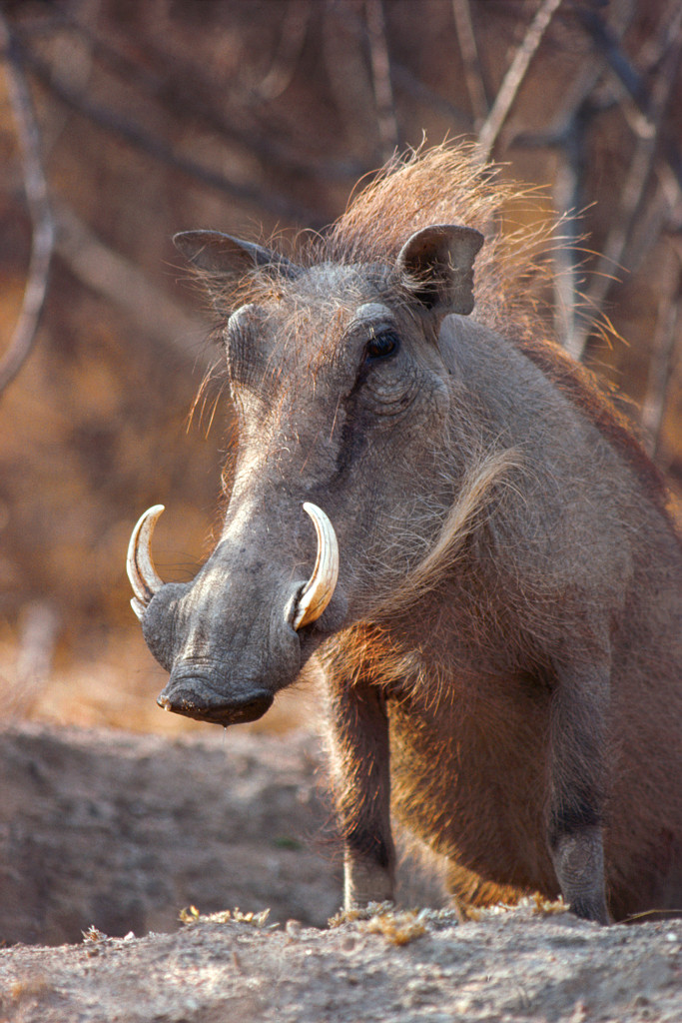
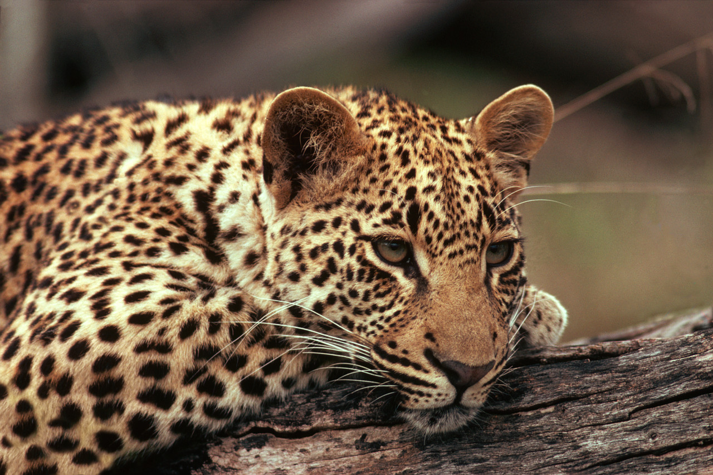

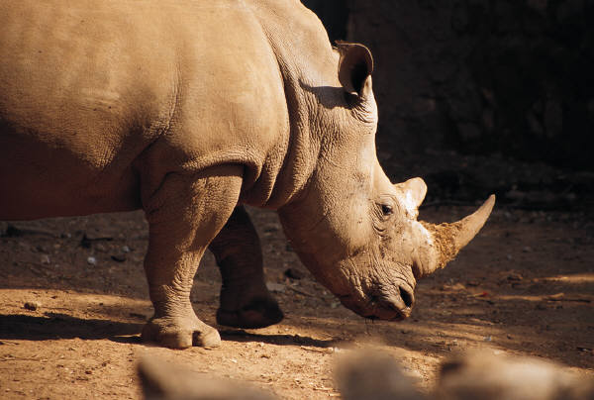

Part IV: Fluency Practice: Follow the four-step fluency practice steps:

1. Read the following excerpt from the text to your teacher. You must focus on pronouncing each word correctly. Take your time and do a great job. Your teacher will then discuss any words that may have been difficult for you. Record your time in the space provided.
2. Read the following excerpt from the text to yourself. Record your second time in the space provided. Ask yourself: Do I understand what happened in the text?
3. Read the following excerpt from the text to a classmate. Record your third time in the space provided. Ask yourself: Is my fluency speed improving?
4. Read the following excerpt from the text to a parent or sibling. Have them sign in the space provided. This will let your teacher know that you completed the fourth step of your fluency practice.

Fluency Goal: Your fluency goal for this excerpt is to cut your time in half from your first reading to your fourth reading. If you do not complete your goal, you need to continue reading this excerpt until you accomplish that goal. When you have reached your goal, write down the main idea (one sentence) of your excerpt on the line provided. You will read this excerpt to your teacher one final time.

For a few moments Muteye hesitated as he considered the two birds and wondered, “How would a man who lives in darkness ever know which bird belonged to him?”
His mind made up, he quickly switched the thin bird for the plump one.
“Your bird is the larger of the two,” he said as he handed the quail over to his companion.. “It will make a fine meal.”
Chirobo stroked the bird’s scraggly wings and thoughtfully passed his fingers along its bony back and breast. Without speaking, he put it into his own sack.
Then the men gathered their traps and began the journey back to the village.
In silence they walked and walked, until they stopped to rest beneath an old baobab tree. Muteye was eager to continue the conversation of the night before, so he took the opportunity to ask his friend a question that had worried him since he was a small boy.
“Why do people fight each other?”

162 words

First Read:__________ Second Read:__________ Third Read:__________ Fourth Read:__________

Parent Signature:_______________________

Main Idea:_________________________________________________________________________________

__________________________________________________________________________________________
Summary Sheet Fiction ©1999 by Sopris West

Directions: Summarize the text you just read using the following procedure. Steps 1-3 will help you with your topic sentence. Steps 4-5 will help you get started on your summary paragraph.
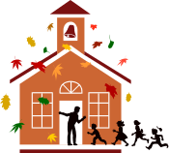
1. Identify what you will be summarizing. Be specific—use names and titles.
The story Princess Harimau and the Tiger

2. Use one of these words (verbs) to help you organize your summary:
tells, lists, describes, explains, compares, gives, shows

3. Finish your thought:
The story Princess Harimau and the Tiger tells the story of a Princess and her friendship with her pet tiger named Shiva.

4. Create a beginning-middle-end outline: Make a list of the important events you would like to include in your summary.
(Use transition words: first, next, then, after that, finally…..)
Beginning (characters, setting)

Middle (problem, events)

End (solution to the problem)

5. Use your Beginning-Middle-End outline to write the summary paragraph:

____________________________________________________________________________________________________________

____________________________________________________________________________________________________________

____________________________________________________________________________________________________________

____________________________________________________________________________________________________________

____________________________________________________________________________________________________________

____________________________________________________________________________________________________________

____________________________________________________________________________________________________________

____________________________________________________________________________________________________________

____________________________________________________________________________________________________________

____________________________________________________________________________________________________________

____________________________________________________________________________________________________________

____________________________________________________________________________________________________________

____________________________________________________________________________________________________________

____________________________________________________________________________________________________________

____________________________________________________________________________________________________________

____________________________________________________________________________________________________________
Be sure to check your paragraph? Does it make sense? Does it look right? Does it sound right?

