Teaching Kids About Revision

https://www.youtube.com/watch?v=RBKqgOvmJ8w

- What step in the writing process does the girl say that she is finished with at 0:13?

- What is wrong with the girl’s idea of writing at 0:26?

- Who read the paper beginning at 0:35?

- What does revising mean? Use the information that begins at 1:00 to help you.

- Are checking for capitals and spelling mistakes part of drafting, revision, or editing? 1:30

- “In revising, you try to _________________ the ________________ of your ideas.” 1:35

- What are you FOUR different ways you can revise your paper? 1:42
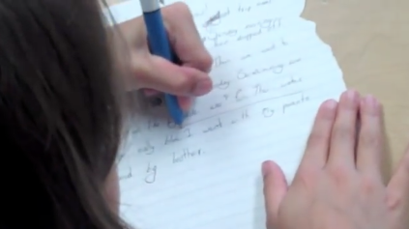
  - A________________
  - S________________
  - M_______________
  - C_______________

Always ask yourself…

Does everything in my story make sense?

Have I done everything possible to express my ideas well?

Have I chosen the best words?

Have I put in enough interesting, important details?
- “The essence of writing is _________________.” 3:10

- At 3:26- 4:45, as the boy is giving ideas, what is the girl doing?

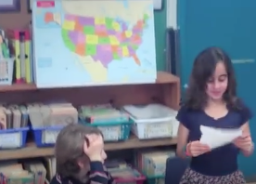
- What is the last sentence the boy says in the video?

