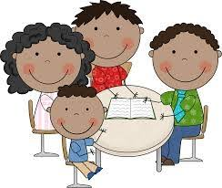
Student Led Conference
3rd Grade: November 2018

File Sharing: (10 minutes)
(Share 1- 3 learning tasks in each of the following subject areas):
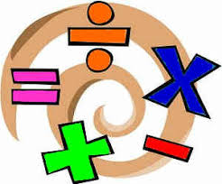
- Math (share work to support conversations)
“In math, I am great at…”
“A challenge I am working on in math is…?”

- Reading (share work to support conversations)
“A skill I am learning in reading is…”
“My favorite genre in reading is…”

- Writing (share work to support conversations)
“A writing piece I am proud of is…”
“An area in writing I want to improve is…”

- Science or Social Studies tasks
(share work to support conversations)
“An interesting topic of learning was… because…,”

Laptop/Digital Sharing (5 minutes) (Choose 1-3 digital learning tools to share that show your learning)
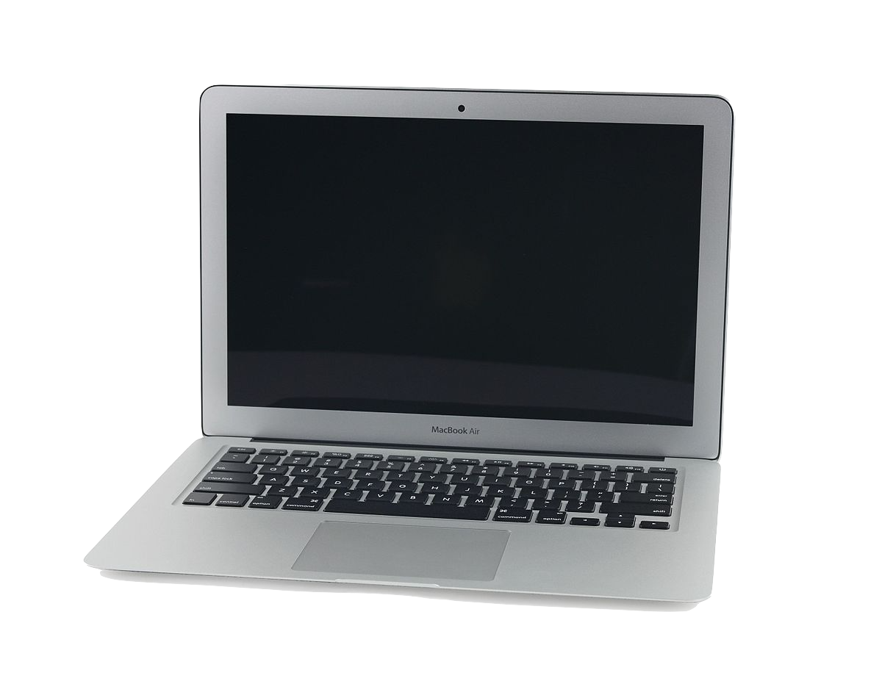
- Reading Recordings | - Spellingcity.com
- RAZ Books You Have Read | - Education.com
- CLIP Movie | - Photos (Class website)

Learning and Life Skills Assessment (November 2018)
Self-management | Self-awareness | Social awareness | Responsible Decision-making
Use the following codes to respond to each area: (I, G, S)
I: Improving. This is an area I am still working on knowing and understanding.
G: Growing. I can do this with guidance, support or reminders. I am working on continuing to build independence in this area.
S: Skilled. I show independence and consistency in this area without support or reminders.
Topics | Student Opinion | Parent Opinion | Teacher Comment
I listen carefully to verbal directions.
I ask questions if I don’t understand or need more direction.
I listen to feedback and use it to improve (school work or behavior)
I can describe my emotions to support people in better understanding me
I can talk about what my needs are (self-advocate for learning or emotional needs)
I am responsible for my own behaviors, classwork, and homework
I can set goals for myself to make improvements
I am honest
I can listen and respond to different ideas other people have
I can recognize how others feel
I can help solve problems when there is conflict
I can share ideas of how to make things fair so we all have equal opportunities
I listen to others’ thinking and ideas
I show consideration and care for my environment (neat, organized, respectful to others’ spaces and property)
I am learning to solve my own problems (socially, academically, personally)
I make decisions for myself that show recognition of safety (ex: not running in the halls)
I make choices that are healthy (eating, friendships, digital connectivity, etc)
I can apply problem-solving skills to challenges that are not easy for me
I choose to use my time productively to maximize learning

GOAL Setting
(1-2 academic skill areas to improve upon)
(1-2 life/learning competencies to improve upon)

Academic Goal #1
Choose academic content subject: (circle one)
MATH READING WRITING SCIENCE

A skill or area of challenge I want to improve in this subject is:

___________________________________________________

Action Steps I will take to make this improvement:
1.
2.

Life /Learning Competency Goal #1:
Choose an area to grow/improve in (circle one):

Self-management Self-awareness Social Awareness

Responsible Decision-Making

A skill or area of challenge I want to improve is:
__________________________________________________________________

Action Steps I will take to make this improvement:
1.
2.

Academic Goal #2
Choose academic content subject: (circle one)
MATH READING WRITING SCIENCE

A skill or area of challenge I want to improve in this subject is:

___________________________________________________

Action Steps I will take to make this improvement:
1.
2.

Life /Learning Competency Goal #2:
Choose an area to grow/improve in (circle one):

Self-management Self-awareness Social Awareness

Responsible Decision-Making

A skill or area of challenge I want to improve is:
__________________________________________________________________

Action Steps I will take to make this improvement:
1.
2.

