ACTIVITY: Rocket launch challenge

Activity idea

In this activity, students use a rocket launch simulation. They change parameters such as mass, thrust and drag to make a rocket go as high as possible and launch a payload 400 km above the ground.

By the end of this activity, students should be able to:
- investigate how thrust, time of thrust and mass of a rocket can be changed to make a rocket go as high as possible
- explore how drag influences the height reached by a rocket
- explore how the speed and forces acting on a rocket change during a launch
- explore how the changing mass of a rocket (as propellant is used and ejected) affects the speed and height of a rocket.

For teachers

Introduction/background

The interactive Rocket launch challenge allows students to choose key parameters in setting up a rocket similar to Rocket Lab’s Electron rocket ready for launch. The challenge is to make the rocket go as high as possible without exploding. If the rocket reaches 400 km above the Earth’s surface, it will be able to release its payload (which would usually be a satellite around 150–225 kg in mass).

The Electron rocket is 17 m high and 1.2 m in diameter and normally has two to three stages of propulsion. This simulation simplifies this to just one stage and makes the rocket continue to rise vertically from the launch pad with no attempt to go into orbit.

For each launch, students can:
- vary the mass of the rocket from 1,200–12,500 kg
- vary the amount of thrust from 100–162,000 N
- this simulation assumes that the thrust is constant for the time that it acts
- vary the thrust time from 0–140 s
- switch drag off (ideal world without air resistance) or on (real world includes drag)
- switch mass change off (ideal world where mass of rocket remains constant) or on (in the real world, rockets lose mass as propellant fuel is burned and ejected from the engines).

The simulation can be paused at any time to check thrust, weight, drag and resultant force values as well as speed and height. There are three simulation speeds available, with the middle one set as the default speed.

At the end of this document are model answers with some commentary for teachers and screen shots that show a variety of results.

What you need

- Access to the interactive Launch simulator challenge
- Copies of the student record sheet Analysing rocket launches.

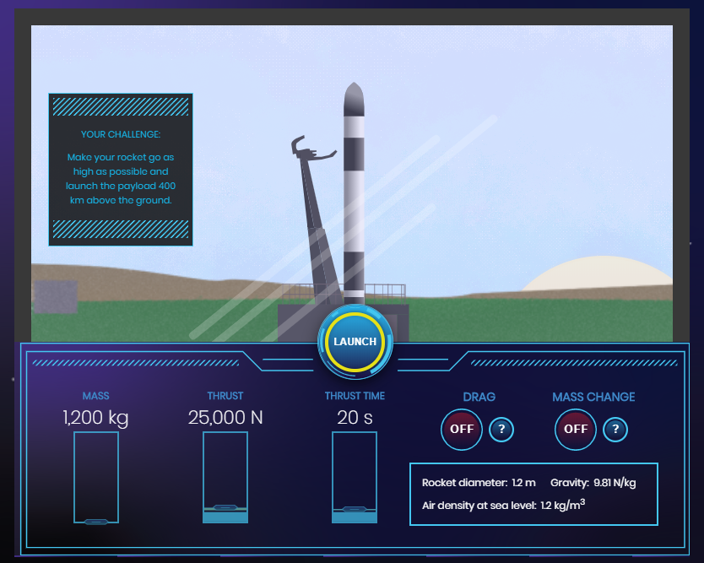

What to do

- Introduce the challenge: to make a rocket go over 400 km high using the interactive Rocket launch challenge.

- Discuss how each of the variables may affect the height reached by the rocket – mass, thrust, thrust time, drag and mass change.

- Discuss that this simulation allows students to investigate an ideal world without drag (by leaving the drag switched off). It is then useful to compare this with the real world where drag makes a great difference.

- Hand out copies of the student recording sheet and ask students to work through it. (Questions 1–10 are recommended for all. There is more available if you want to go into greater depth.)

For students

Activity 1: Use the rocket launch simulation to make a rocket go as high as possible
Activity 2: How does drag influence the height reached by a rocket?
Activity 3: How does the loss of mass from the rocket engine affect motion?

For students – Analysing rocket launches

Activity 1: Use the rocket launch simulation to make a rocket go as high as possible

Leave drag and mass change switched off and change values for the first three columns to try to get each rocket flying as high as possible.

- Changing thrust.

Launch settings |  |  |  |  | Launch results
Mass of rocket (kg) | Thrust  (N) | Time of thrust (s) | Drag | Mass change | Height reached (m) | Maximum speed (m/s)
8,000 | 100,000 | 100 | OFF | OFF
8,000 | 130,000 | 100 | OFF | OFF
8,000 | 160,000 | 100 | OFF | OFF

Challenge: For a 8,000 kg rocket and a thrust time of 100 s, what thrust makes the rocket reach a height of 69 km? Answer: Thrust = _____________ N

- Changing time of thrust.

Launch settings |  |  |  |  | Launch results
Mass of rocket (kg) | Thrust  (N) | Time of thrust (s) | Drag | Mass change | Height reached (m) | Maximum speed (m/s)
8,000 | 130,000 | 60 | OFF | OFF
8,000 | 130,000 | 100 | OFF | OFF
8,000 | 130,000 | 140 | OFF | OFF

Challenge: For a 8,000 kg rocket and a thrust of 130,000 N, what thrust time makes the rocket reach a height of 34 km? Answer: Thrust time = ________ s

- Changing mass.

Launch settings |  |  |  |  | Launch results
Mass of rocket (kg) | Thrust  (N) | Time of thrust (s) | Drag | Mass change | Height reached (m) | Maximum speed (m/s)
6,000 | 130,000 | 100 | OFF | OFF
8,000 | 130,000 | 100 | OFF | OFF
10,000 | 130,000 | 100 | OFF | OFF

Challenge: For a thrust of 130,000 N and a thrust time of 100 s, what rocket mass makes the rocket reach a height of 220 km? Answer: mass = ________ kg

- Find the maximum height you can reach for each rocket.

Launch settings |  |  |  |  | Launch results
Mass of rocket (kg) | Thrust  (N) | Time of thrust (s) | Drag | Mass change | Height reached (m) | Maximum speed (m/s)
12,000 |  |  | OFF | OFF
10,000 |  |  | OFF | OFF
8,000 |  |  | OFF | OFF
6,000 |  |  | OFF | OFF
4,000 |  |  | OFF | OFF

- What was your highest distance? _____________ km

- What did you do to make your rocket travel higher?

- Using your results above, what three things can be done to make a rocket go faster and higher?
- The mass of the rocket can be increased/decreased
- The thrust can be increased/decreased
- The time of the thrust can be increased/decreased

- What happens to the speed of the rocket while the engine is creating thrust?
- The speed of the rocket increases/decreases/stays the same

- When is the speed of the rocket at its fastest?

- What happens to the speed of the rocket when the engine has finished producing thrust?
- The speed of the rocket increases/decreases/stays the same

- Why does a rocket keep moving upwards even after the thrust has finished?

- What is the minimum thrust needed to launch each of the following rocket masses?

Mass of rocket (kg) | 12,000 | 10,000 | 8,000 | 6,000 | 4,000
Minimum thrust (N)

- Why does a rocket with more mass need more thrust to launch it?

Activity 2: How does drag influence the height reached by a rocket?

Drag is the air resistance that opposes the motion of a rocket. There is always drag as an object moves through the air

- For each of the following, record results for a rocket if there was no drag acting (ideal world) and then compare the results when drag is switched on (real world).

Launch settings |  |  |  |  | Launch results
Mass of rocket (kg) | Thrust  (N) | Time of thrust (s) | Drag | Mass change | Height reached (m) | Maximum speed (m/s)
8,000 | 160,000 | 100 | OFF | OFF
4,000 | 80,000 | 100 | OFF | OFF
2,000 | 40,000 | 100 | OFF | OFF
8,000 | 160,000 | 100 | ON | OFF
4,000 | 80,000 | 100 | ON | OFF
2,000 | 40,000 | 100 | ON | OFF

- Which rocket was affected the most by drag?

Activity 3: How does the loss of mass from the rocket engine affect motion?

Launch settings |  |  |  |  | Launch results
Mass of rocket (kg) | Thrust  (N) | Time of thrust (s) | Drag | Mass change | Height reached (m) | Maximum speed (m/s)
8,000 | 140,000 | 100 | OFF | OFF
8,000 | 140,000 | 100 | OFF | ON

- How does the rocket’s motion change when mass change is switched on?

- With drag and mass change both switched on what is the greatest height you can reach with any combination of launch settings? This is the simulation’s ultimate challenge.
Note that the simulation will not allow you to choose the smallest mass and the greatest thrust for the greatest time. As you increase the thrust, the minimum rocket mass also increases. Also, some setting combinations produce great stresses on the rocket during flight and it will explode. This is most embarrassing and very costly. Choose carefully.

Launch settings |  |  |  |  | Launch results
Mass of rocket (kg) | Thrust  (N) | Time of thrust (s) | Drag | Mass change | Height reached (m) | Maximum speed (m/s)
 |  |  | ON | ON

For teachers – Analysing rocket launches

Activity 1: Use the rocket launch simulation to make a rocket go as high as possible

Leave drag and mass change switched off and change values for the first three columns to try to get each rocket flying as high as possible.

- Changing thrust.

Launch settings |  |  |  |  | Launch results
Mass of rocket (kg) | Thrust  (N) | Time of thrust (s) | Drag | Mass change | Height reached (m) | Maximum speed (m/s)
8,000 | 100,000 | 100 | OFF | OFF | 17,000 | 270
8,000 | 130,000 | 100 | OFF | OFF | 53,000 | 643
8,000 | 160,000 | 100 | OFF | OFF | 105,000 | 1,019

Challenge: For a 8,000 kg rocket and a thrust time of 100 s, what thrust makes the rocket reach a height of 69 km? Answer: Thrust = 140,000 N

- Changing time of thrust.

Launch settings |  |  |  |  | Launch results
Mass of rocket (kg) | Thrust  (N) | Time of thrust (s) | Drag | Mass change | Height reached (m) | Maximum speed (m/s)
8,000 | 130,000 | 60 | OFF | OFF | 19,000 | 385
8,000 | 130,000 | 100 | OFF | OFF | 53,000 | 643
8,000 | 130,000 | 140 | OFF | OFF | 105,000 | 905

Challenge: For a 8,000 kg rocket and a thrust of 130,000 N, what thrust time makes the rocket reach a height of 34 km? Answer: Thrust time = 80 s

- Changing mass.

Launch settings |  |  |  |  | Launch results
Mass of rocket (kg) | Thrust  (N) | Time of thrust (s) | Drag | Mass change | Height reached (m) | Maximum speed (m/s)
6,000 | 130,000 | 100 | OFF | OFF | 132,000 | 1,184
8,000 | 130,000 | 100 | OFF | OFF | 53,000 | 643
10,000 | 130,000 | 100 | OFF | OFF | 21,000 | 320

Challenge: For a thrust of 130,000 N and a thrust time of 100 s, what rocket mass makes the rocket reach a height of 220 km? Answer: mass = 5,000kg

- Find the maximum height you can reach for each rocket.

Launch settings |  |  |  |  | Launch results
Mass of rocket (kg) | Thrust  (N) | Time of thrust (s) | Drag | Mass change | Height reached (m) | Maximum speed (m/s)
12,000 | 162,000 | 140 | OFF | OFF | 50,000 | 519
10,000 | 162,000 | 140 | OFF | OFF | 105,000 | 900
8,000 | 162,000 | 140 | OFF | OFF | 216,000 | 1,468
6,000 | 162,000 | 140 | OFF | OFF | 489,000 | 2,419
4,000 | 162,000 | 140 | OFF | OFF | 1,456,000 | 4,326

- What was your highest distance? 1,456 km

- What did you do to make your rocket travel higher?
Gave the rocket more thrust for a longer time of thrust

- Using your results above, what three things can be done to make a rocket go faster and higher?
- The mass of the rocket can be increased/decreased
- The thrust can be increased/decreased
- The time of the thrust can be increased/decreased

- What happens to the speed of the rocket while the engine is creating thrust?
- The speed of the rocket increases/decreases/stays the same

- When is the speed of the rocket at its fastest?
At the moment the time of thrust ends

- What happens to the speed of the rocket when the engine has finished producing thrust?
- The speed of the rocket increases/decreases/stays the same

- Why does a rocket keep moving upwards even after the thrust has finished?
The rocket keeps on moving upwards so long as it has upwards speed/momentum

- What is the minimum thrust needed to launch each of the following rocket masses?

Mass of rocket (kg) | 12,000 | 10,000 | 8,000 | 6,000 | 4,000
Minimum thrust (N) | 117,800 | 98,200 | 78,500 | 58,900 | 39,300

- Why does a rocket with more mass need more thrust to launch it?
The rocket has more weight if it has more mass and so more thrust is needed to overcome the more weight.

Activity 2: How does drag influence the height reached by a rocket?

Drag is the air resistance that opposes the motion of a rocket. There is always drag as an object moves through the air

- For each of the following, record results for a rocket if there was no drag acting (ideal world) and then compare the results when drag is switched on (real world).

Launch settings |  |  |  |  | Launch results
Mass of rocket (kg) | Thrust  (N) | Time of thrust (s) | Drag | Mass change | Height reached (m) | Maximum speed (m/s)
8,000 | 160,000 | 100 | OFF | OFF | 104,000 | 1,017
4,000 | 80,000 | 100 | OFF | OFF | 105,000 | 1,021
2,000 | 40,000 | 100 | OFF | OFF | 105,000 | 1,021
8,000 | 160,000 | 100 | ON | OFF | 91,000 | 931
4,000 | 80,000 | 100 | ON | OFF | 79,000 | 850
2,000 | 40,000 | 100 | ON | OFF | 61,000 | 718

- Which rocket was affected the most by drag?
The one with the smallest mass

Activity 3: How does the loss of mass from the rocket engine affect motion?

Launch settings |  |  |  |  | Launch results
Mass of rocket (kg) | Thrust  (N) | Time of thrust (s) | Drag | Mass change | Height reached (m) | Maximum speed (m/s)
8,000 | 140,000 | 100 | OFF | OFF | 69,000 | 770
8,000 | 140,000 | 100 | OFF | ON | 207,000 | 1,655

- How does the rocket’s motion change when mass change is switched on?
The rocket accelerates more, reaching a much higher maximum speed (at 100 s) and rises to a much greater height (almost 3x higher in this case).

- With drag and mass change both switched on what is the greatest height you can reach with any combination of launch settings? This is the simulation’s ultimate challenge.
Note that the simulation will not allow you to choose the smallest mass and the greatest thrust for the greatest time. As you increase the thrust, the minimum rocket mass also increases. Also, some setting combinations produce great stresses on the rocket during flight and it will explode. This is most embarrassing and very costly. Choose carefully.

Launch settings |  |  |  |  | Launch results
Mass of rocket (kg) | Thrust  (N) | Time of thrust (s) | Drag | Mass change | Height reached (m) | Maximum speed (m/s)
8,070 | 150,000 | 140 | ON | ON | 1,488,000 | 4,625

Also:
7,540 | 140,000 | 140 | ON | ON | 1,452,000 | 4,574
8,730 | 162,000 | 140 | ON | ON | 1,451,000 | 4,570
Etc.

These results show that there are a large number of launch settings that can give a roughly comparable maximum height.

You are doing very well if you can reliably get the rocket over 1,400 km. The screen shots below show the variation found in repeating the top launch setting using different simulation speeds and different web browsers. This models the random variations that occur in reality. No rocket launch is ever identical!

