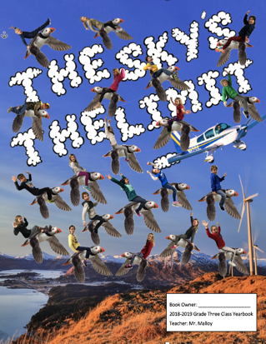
Mr. Malloy’s Classroom Yearbook
Writing Reflection Template
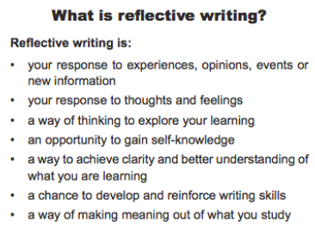

- Write a Title about the Activity
- Tell the reader about what the activity is all about on the left side of the paper.
- Write at least THREE sentences that each tell the person something you remember, or had to do during this activity.

- Write at least TWO sentences that tell the reader two things you learned during this activity.

- You have a choice to either write a conclusion sentence that tells how you felt about this activity,
or…
- You can write a question that you still have about this activity.
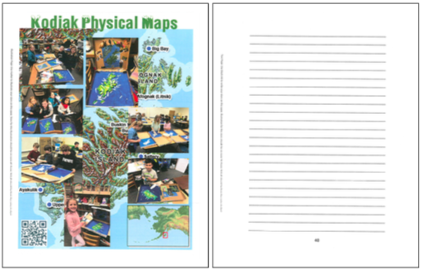

________Kodiak Physical Maps_________
___________________________________
I made a physical map of Kodiak Island in__ class. We built mountains and labeled____ villages, and water areas. I got to paint my pizza box with spray paint! We colored the lower elevations green, the higher ones__ yellow, and the highest parts brown. I___ learned that Kodiak Island is the second__ largest island in the entire United States! I also learned that Ouzinkie is located on a_ different island! I loved this activity______ because Kodiak is a lot bigger than I______ thought it was. ______________________ ___________________________________
___________________________________

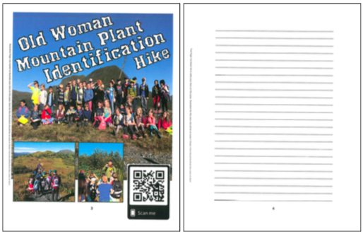

_____Old Woman Mountain Hike______
___________________________________
Both third grade classes hiked up Old Woman Mountain the first week of school to learn about Kodiak plants. Mr. Malloy lead the way, pointing out yellow identification cards that had answers to questions I had to answer. We ate lunch at the top, in a volcanic ash pit. It was eazier coming down than it was going up. I___ learned that Kodiak has a lot of different plants. Pooshki is a plant I have to watch out for. I was worried about how far we were hiking, but had a great time and learned about some cool plants!_____________________

