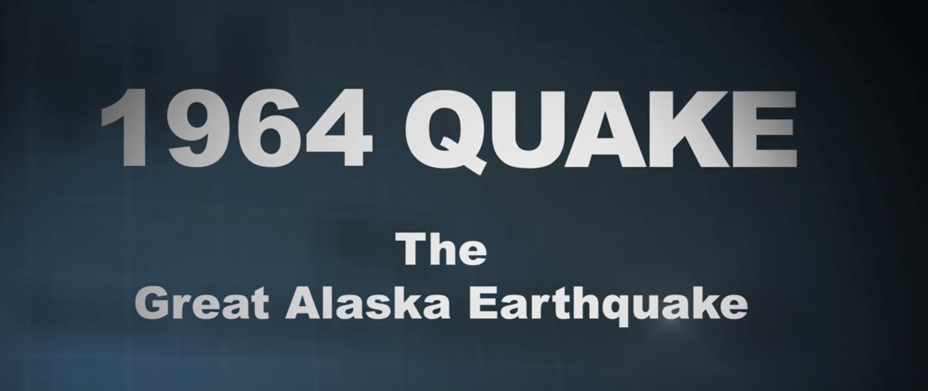
Name:_______________________________
https://www.youtube.com/watch?v=jvl-4IWjHXo

- In 1964, Alaska was shake by the largest earthquake ever recorded. It had a magnitude of _____________. 0.20

- In 1964, scientists thought the earthquake happened by:
  - Movement of the Earth’s plates
  - An erupting volcano
  - They did not know why

- Because there were no fault lies, scientists were confused about the 1964 earthquake. Even after months of study, the cause of the large earthquake remained a ____________________. 0:50
- What are the names of the FIVE plates that surround the earth? 0:57
1.
2.
3.
4.
5.

5. What are the names of the two crusts that are shown in the diagram at 1:08
1.
2.

6. The large “crack” shown at 1:34 is called a ________________. (Hint: look at #3)

7. How deep do scientists drill to take core samples of earth to study? 1:50

8. During the 1964 earthquake, there were many tsunamis. Within minutes, one wave was created that was ______ stories high. 2:16

9. The earthquake was so strong, that it wreaked havoc in 3 other states. Which states were they? 2:22
1.
2.
3.

10. What did the city of Valdez do when they found out that their town was in a high-earthquake zone? 3:25

