How to make a video using clips on an iPad

1. Tap on the clips app 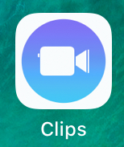. If you already have projects in clips, tap “create new”.
You may need to tap on the folders to see create new.

2. Hold the red bar down to record using the CAMERA. The circle arrows on the top change the direction of the camera.
-Record over a pre-made picture using POSTERS
-Add pictures and videos you’ve already saved by taping LIBRARY

3. Watch your video.
To edit:
- click on the small pictures on the bottom to “trim” parts
-if you need to record again, tap the “done” in the upper right-hand corner
-you can re-arrange your recordings/ “clips” by dragging them. If you messed up in the middle, you can trim that part out, record that part again, then drag it in.
-The colorful star allows you to add filters, text, stickers and emoji.

7. To name your file, tap the folders in the top left. Make sure your project is selected, then tap the three dots on the top right of the screen. Name it as your teacher describes. If they don’t tell you how, try to name it with something that identifies who you are and the assignent.

8. Tap the share box in the bottom right corner (rectangle with an up arrow in it) to save it to your OneDrive.

9. Scroll to find OneDrive and tap it. Upload it to the appropriate folder in OneDrive.

10. Submit your video by sharing the one-drive link or copying and pasting the link.
(refer to “sharing from OneDrive directions” if you’re not sure how)

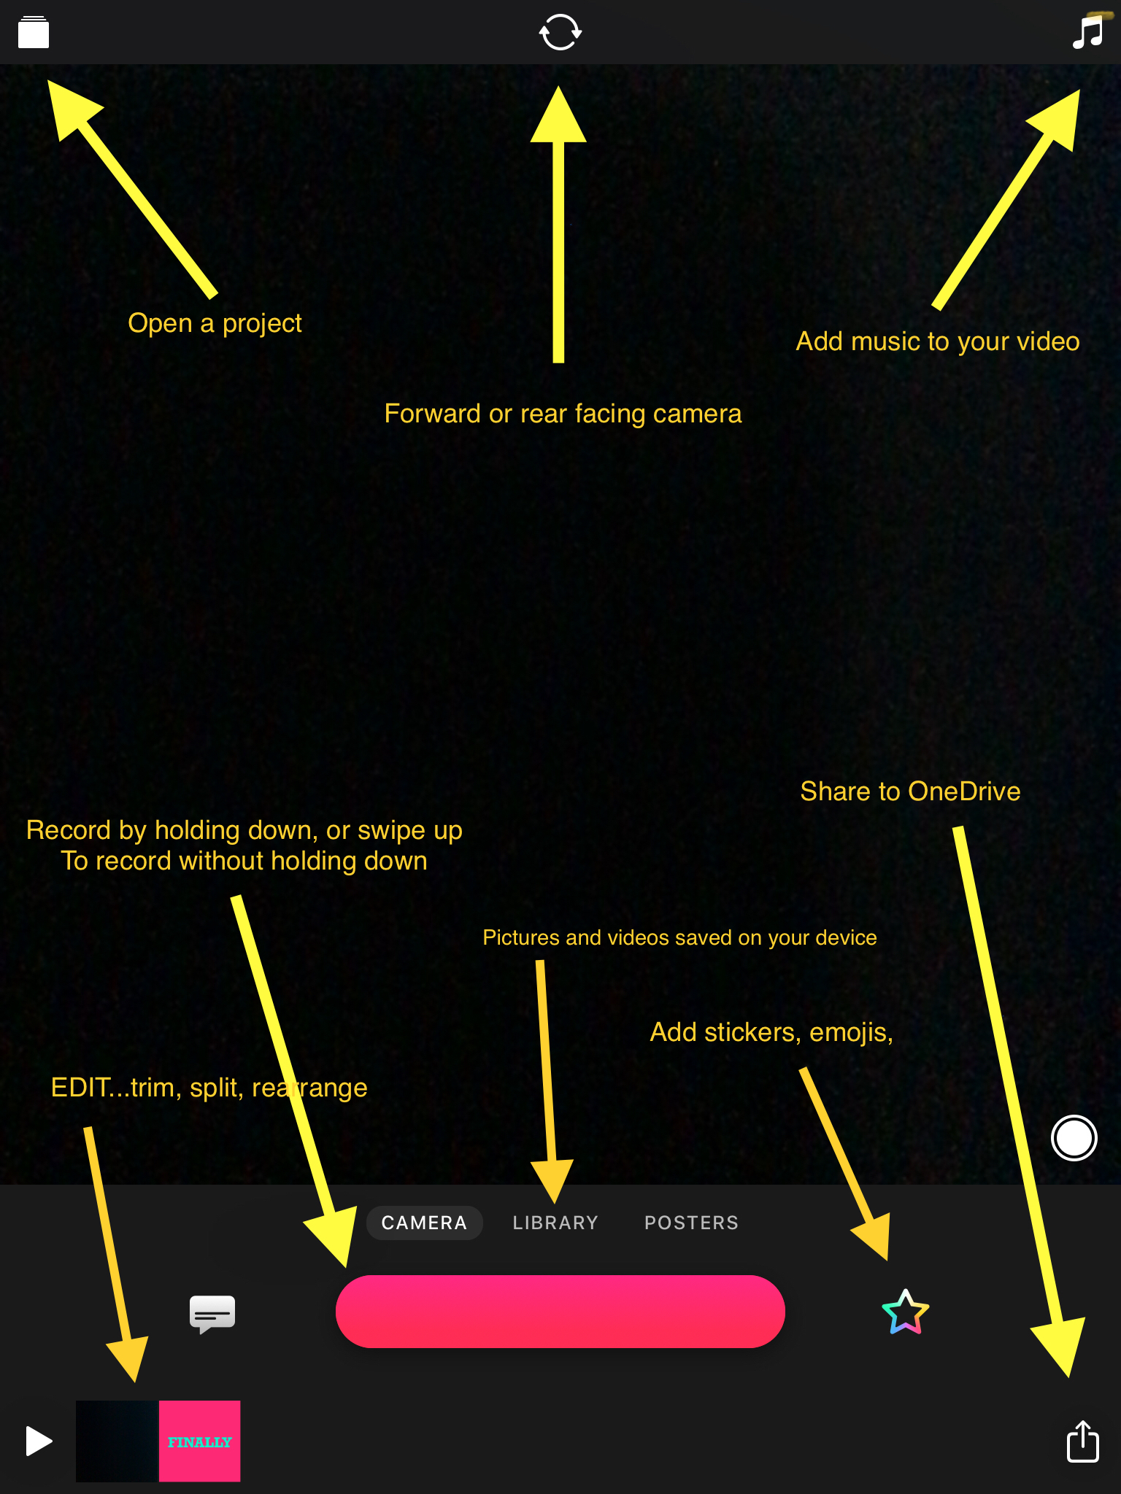
If you are on your phone instead of iPad, the screen will look slightly different.
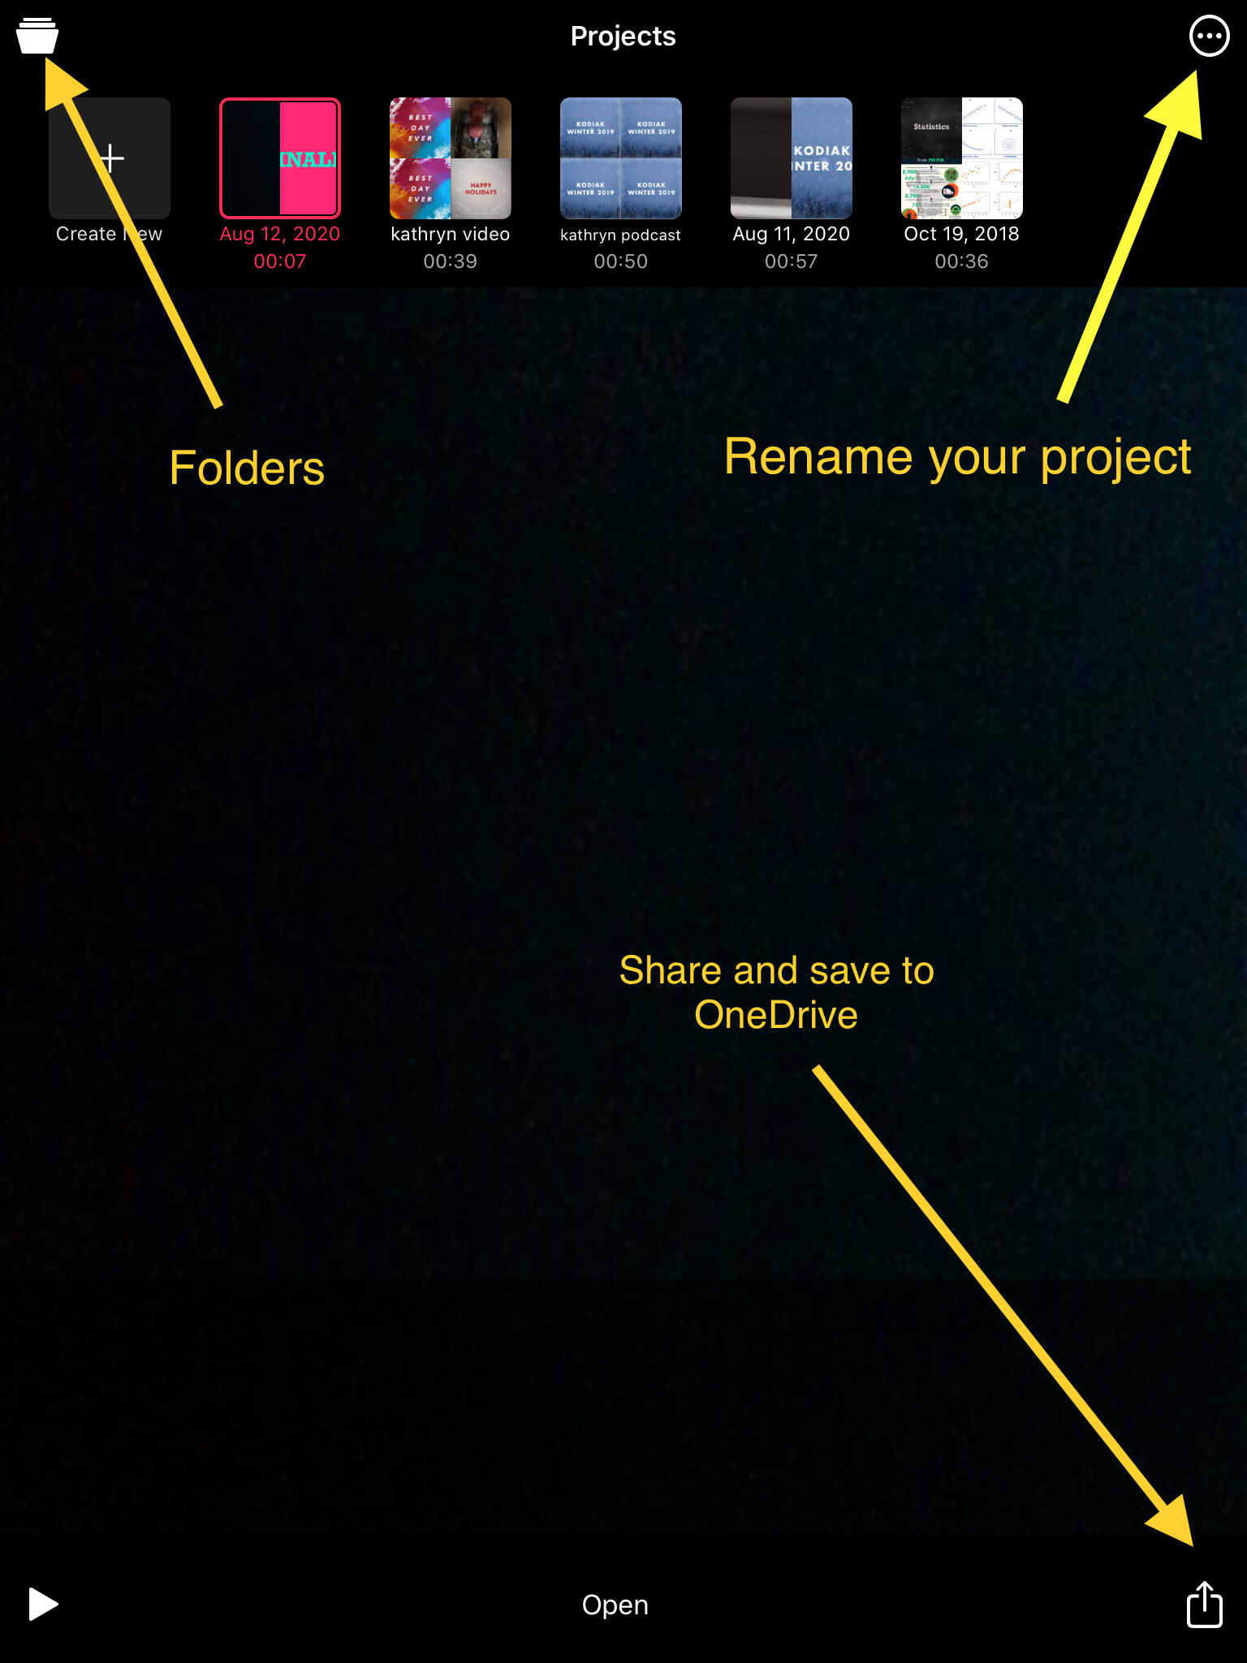
If you are on your phone instead of iPad, the screen will look slightly different.

