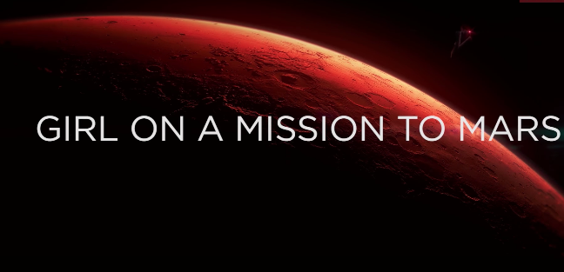
NAME:___________________________

What color is Mars? 0:04

When did Alyssa first become interested in going to Mars? 0:05

What machine do you THINK is behind Alyssa at 0:27?

What is the title of this movie? 0:32

What sport is Alyssa playing at 1:14?

What skill are astronauts practicing when they are in the machine on 1:27? What is your BEST GUESS?

Has Alyssa completed ALL of NASA’s Space Camps in the world? 1:45

Which did Alyssa get first, her driver’s license or her rocket permit? 1:49

How many engines does the shuttle rocket have at 1:49?

How many languages does Alyssa speak? 2:04

Who is on the screen at 2:30?

What are the BIG PLANS for Mars? 3:21

What is the name of Alyssa’s best friend? 4:39

How many black stripes are on Alyssa’s uniform at 5:00?

Out of THOUSANDS of people who wanted to go to Mars, how many is NASA excepting? 5:05

How is the astronaut staying in shape at 5:41?

What does Possum Academy prepare people for? 6:00

Why has NASA determined at 2033 is the best time to launch the shuttle to Mars? 6:38

