Name:_________________________ Date: __________________

The 5 Regions of Alaska
www.youtube.com/watch?v=1tv0SYmpUE0

How many square miles is Alaska? 0:52

How many lakes are in Alaska? 1:01

How many rivers are in Alaska? 1:04

Introduction 1:45

Far North Region 2:18

What are the boundaries of the Far North Region?

What is permafrost?

How deep can permafrost go in the Far North Region? 2:35

How many people live in the Far North Region? 2:40

What kind of whales do the native people of the Far North region harvest each year to feed their communities? 2:50

Why do people hunt and kills large whales instead of just killing smaller animals for their family? 3:25

What is the name of the northern-most town in Alaska? 3:40
Who gets the largest share of the whale when a community butchers one? 4:15

What other animals are hunted in the Far North region of Alaska? (name 3) 4:30

Can you drive to the Far North Region?4:55

How long is the road from Anchorage to Fairbanks to Dead Horse?

Can you drive to Barrow?5:08
At 5:20, the far North region of Alaska is over.
Name:_________________________ Date: __________________

The 5 Regions of Alaska
www.youtube.com/watch?v=1tv0SYmpUE0

South East Region 5:20

How many people are in this region 5:32?

Name FIVE popular towns to visit in this area 5:42?

1.____________________________
2.____________________________
3.____________________________
4.____________________________
5.____________________________
How many people come to visit Alaska each year? 5:46

What large animal is breathing on the screen at 6:06?

How much precipitation (rain) does this area receive annually (each year)? 6:15
True or False (circle the correct answer. The largest temorate rainforest in the world is in the South East Region of Alaska? 6:20

True False

What THREE types of trout can be caught here? NOT SALMON!!! 8:00

1.____________________________
2.____________________________
3.____________________________

Which two Native Alaska groups lived in this region? 8:15
1.____________________________
2.____________________________
What did these native cultures make that people from all over the world come to see? 8:22

What animal was the master carpenter studying and preparing to carve into the totem pole at 8:43?
What cultural activity were the natives of Ketchikan doing at 9:29?

What was the name of the famous trail that people hiked when they were searching for GOLD in Skagway? 9:28

What country were the “gold fields” located? 9:40

When was the White Pass & Yukon Route Railway completed? 9:58
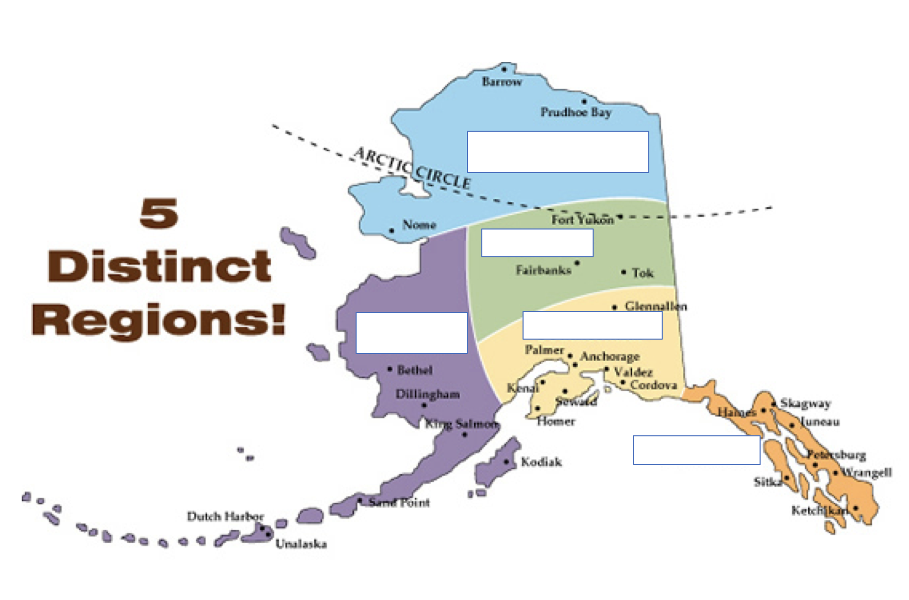

Name:_________________________ Date: __________________

The 5 Regions of Alaska

The Southwestern Region of Alaska begins at 9:59

What divides the cold Berring Sea from the warmer Pacific Ocean? 10:27

What kind of islands are the Aleutian Islands? 10:30

What does the man wearing the hat have on his back at 10:47?

How many tall trees do you see on the land at 11:00?

What city is pictures at 12:05?

Is that city larger or smaller than Kodiak?

What animal is Mr. Csonka talking about at 12:13?

What is the traditional way of halibut fishing that is talked about at 12:57?

Name:_________________________ Date: __________________

The 5 Regions of Alaska

What Western region island in Alaska is home to the largest brown bears in the world? 12:23

What national park holds the highest concentration of brown bears? 13:27

How many bears are estimated to live in the park? 13:29

How many sockeye salmon return to Bristol Bay each year? 13:39

What large member of the deer family is pictured at 14:01?

Which three western Alaska cities are focused on at 14:22?

What are the only two ways to reach smaller villages or towns in this region that do not have airports? 14:20

100 years ago, this city was one of the most populated in the state because of it’s gold rush. What city was it? 14:37

When did this gold rush begin? 14:40

Name:_________________________ Date: __________________

The 5 Regions of Alaska
The Interior Region of Alaska Starts at 15:16
Between which two mountain ranges does the Interior Region of Alaska fit between? 15:17

Between the ______________________________ and the

____________________________

Temperatures in this region can reach close to 90 degrees Fahrenheit in which two months? 15:28

____________________ and ______________________

What is the name of the largest city in the Interior Region of Alaska? 15:30

_________________________________

What are the two ways can you reach this city? 15:33

____________________ and ______________________
What is the name of the most popular destination in this region? 15:36

___________________ ________________ _______________
How many acres is this Park? 15:41

Which United States State is this park larger than? 15:44

How many feet tall is Mount Denali? 15:51

List the FIVE animals that were said to make the interior of Alaska home at 15:58.
1.
2.
3.
4.
5.

How many miles have the salmon swam when they reach the interior of Alaska? 16:20

What other activity to people try and get rich at if they are not fishing? 16:34

What happens in Fairbanks during February and March each year? 16:50

Name:_________________________ Date: __________________

The 5 Regions of Alaska

The South-central Region of Alaska begins at 17:20

What physical landform is shown in the water at 17:25?

What color is the south-central region of Alaska on the map at 17:44?

The South-central region extends from the bottom of the _____________ _____________________ to the edge of Prince William _______________ to the Wrangle _______________. 17:45

Can you find ALL FIVE SPECIES of Pacific Salmon in both fresh water AND salt water in this region? 17:50

YES or NO

In cursive, write the FOUR city names that appear on the map at 18:11.

1.
2.
3.
4.

What National Park is shown at 18:35?

From Anchorage, how many glaciers can you travel to that can be walked to or be taken by boat? 18:40

What city, in the Wangle mountains, is the ferry boat that we see in Kodiak named after? 18:55

Nearly __________ million dollars worth of copper was taken out of this city. 19:00

How did the Wrangle Copper Company get the copper ore out of the area? 19:20

