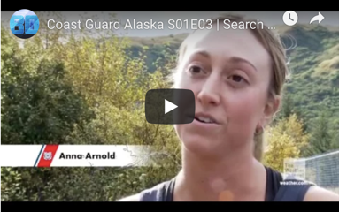
Coast Guard Alaska S01E03 | Search and Rescue (SAR)
Scavenger Hunt
Use the link to watch and listen to this YouTube video. Please note that the answer can be found at the time stamp at the end of each question. It is best to watch the video all the way through and push pause when you get to the time stop point.
PART 1
- What did the Coast Guard doctor say is his number one job? 0:29

- What time did LT Matt Breckel, the helicopter pilot get an alarm call about the emergency? 1:10

- Where was the emergency at that the Coast Guard had to fly to from Kodiak? 1:34

- What does SAR stand for? 1:43

- What vehicle is in the background at 2:05?
- Normally, how many minutes does a person have in the cold waters of Alaska before they need to worry about their life? 2:07

- What three things did the boat survivors do to help themselves and the Coast Guard to find them? 2:40
      - .
      - .
      - .

- How did the crew get the boat survivors into the helicopter without the helicopter needing to land on the water? 3:40

- When is a mission complete? 6:07

- What did the coast guard rescue swimmer say that saving a person’s life was like at 7:57?

