Name: ______________________
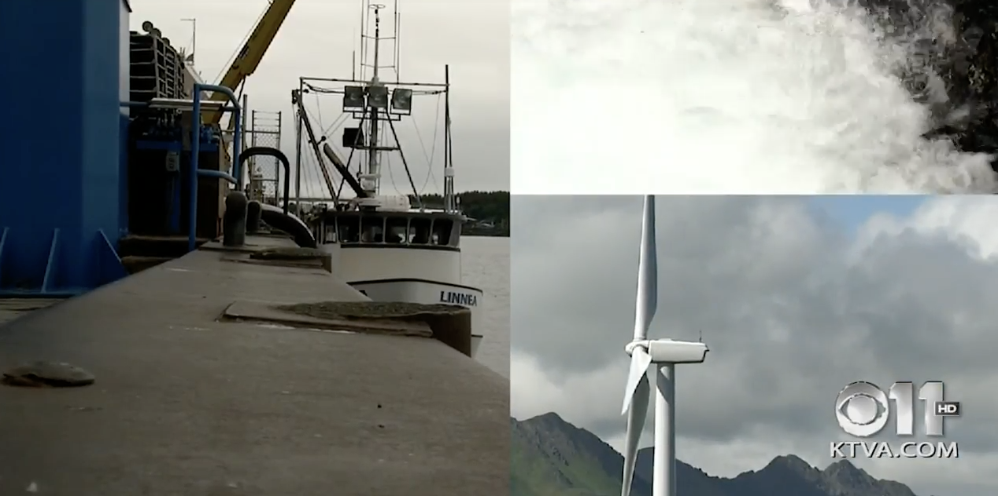
Renewable Alaska
www.youtube.com/watch?time_continue=165&v=fZpKva3-yvY

1. At 0:29, what is the title on the front page of the newspaper?

2. Starting at 0:52 and listening carefully until 1:41 how many times do the two reporters say “um”?

3. What two natural elements do the people of Kodiak use to help with their energy collection? 1:59

4. What percent of Kodiak’s energy comes from the Terror Lake Dam? 2:05

5. How far does the water drop from Terror Lake into the Hydro-plant? 2:33

6. What type of metal are the generators made out of? 2:42

7. How much money does it cost for the hydroplant to work for one day? 2:51

8. How much does it cost for the diesel gas plant (that is across the street from the Powerhouse restaurant), cost to work for one day? 2:56

9. What is the name of the Kodiak Electric Association Board President? 3:27

10. The wind turbines on Pillar Mountain generate enough power to replace ___.___ MILLION gallons of diesel fuel each year! 3:58

11. How much money does using the wind turbines save Kodiak every year? 4:01

12. Since 2011, how much money have the wind turbines saved Kodiak total? 4:08

13. How many miles of ocean does the Kodiak Coast Guard base look after? 5:48

14. What percent of all the energy KEA (Kodiak Electric Association) makes does the Coast Guard base use? 5:57

15. How many building does the climate control center on base keep track of? 6:12

16. What is the title of Amy White at 6:20?

17. What is the name of the fishing boat that is pictured at 7:08?

18. How many batteries are used to store and save energy that the wind turbines produce? 7:19

19. How fast does the power switch from the wind turbines power to the hydropower when the wind stops? 7:30

20. How many inches of rain each year does Kodiak get? 8:39

21. Please write the amount of money that the wind turbine project cost in total. 8:58

22. How long will the savings of using wind power pay for the cost of it? 9:09

23. There is only ONE city in America that uses 100% renewable energy (not Kodiak). What is it’s name? 9:33

